Homework 4 Cryptography

- If Bob happens to find two different messages M1 and M2 (each has 64 bytes), such that SHA256(M1) = SHA256(M2). Can you find another pair M3 and M4, such that SHA256(M3) = SHA256(M4)? Show an example.
  - SHA256 is a very notable encryption algorithm as it is known to not have any or very low collisions, in that it is collision resistant.
  - If there is an M1 and M2 (and M1 != M2) so that SHA256(M1) = SHA256(M2), then this would be a collision.
  - If M1 and M2 exist, then there most likely is another pair, M3 and M4, that can also cause a collision using SHA256.
  - As there are no known collision pairs, I personally cannot find another pair M3 and M4 that will create the same hash.
  - A good example brought up online would be the pigeonhole principle, where in a finite number of spaces, there can be a collision in a specific location. In this case, the 256 bits would be the specific holes, and finding an M1 and M2 that map to the same hole implies that there can be a collision. Expanding this out, this therefore theoretically means that there can be another pair, M3 and M4, that will create a collision.

- In the PKCS#1 v1.5 and OAEP padding schemes, the first byte of the padding is always 00, what is its main purpose?
  - Normal RSA encryption is deterministic, in that if you encrypt a message m, you will always get cyphertext c. This is usually unsafe as you can brute force many messages m’ until you get a c’ = c, therefore telling you that m’ = m.
  - To beat this, a padding is added at the beginning
  - According to the documentation: “The leading 00 octet ensures that the encryption block, converted to an integer, is less than the modulus.”
  - In the encryption formula: hashFunction(m) = m^{e} % n = c
  - The literal definition given means that the purpose of the leading 00 is to make sure that new m () is in the range of n.
  - Source: https://www.rfc-editor.org/rfc/rfc2313.html#:~:text=The%20leading%2000%20octet%20ensures%20that%20the%20encryption%0A%20%20%20%20%20%20%20%20%20%20%20%20%20block%2C%20converted%20to%20an%20integer%2C%20is%20less%20than%20the%20modulus.

- Both AES-128-CBC and RSA use paddings, but their purposes are different. What are their differences?
  - AES-128-CBC is a 128-bit block cipher using CBC (Cipher Block Chaining). As all messages are not of the same length, the amount of blocks used will be different, but all the blocks should be filled. Since, once again, not all messages are the same or are not always given to fit a 128-bit block perfectly, a padding is added at the end to make the message fit.
  - RSA is a public key cryptographic method. RSA utilizes padding since it is naturally a deterministic algorithm, meaning that encrypting m will always give the same c. To beat this vulnerability, padding can be used to add “randomness” to now make the algorithm nondeterministic.

- The following is an X.509 certificate.
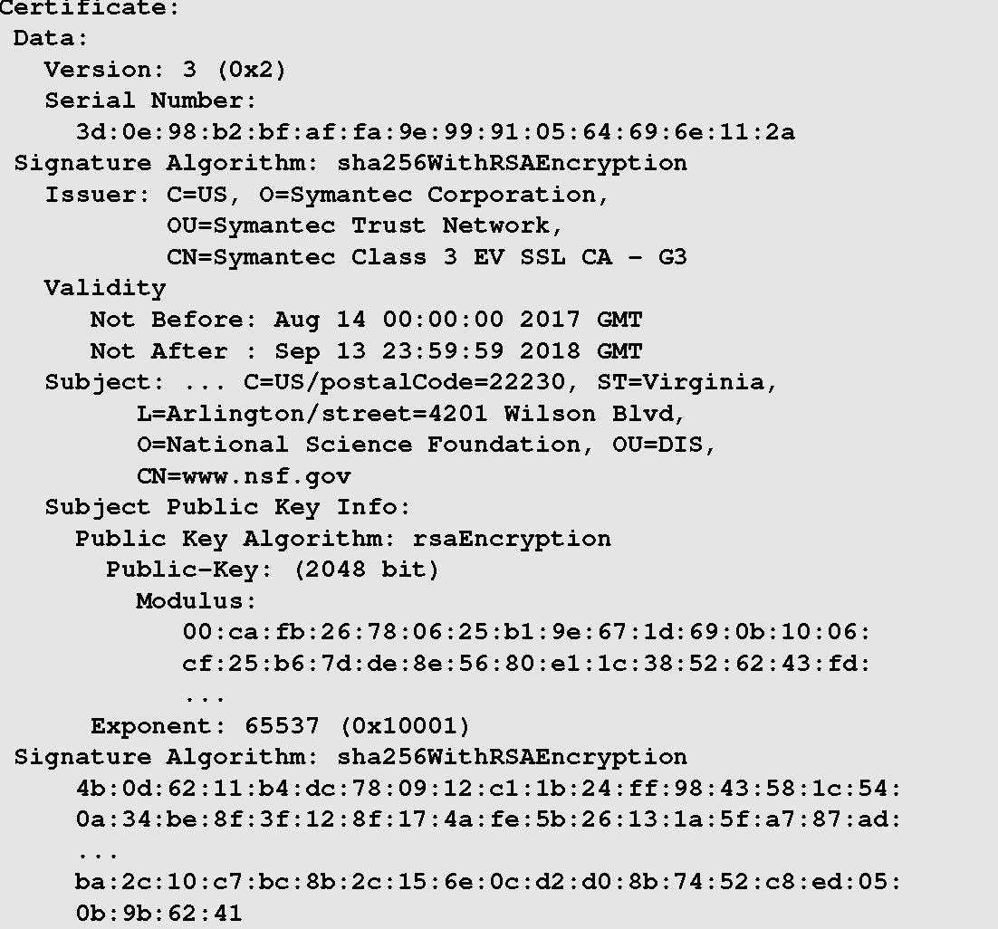

  - Who issues the certificate?
    - Symantec Corporation (Symantec Trust Network)
  - Who is the owner of the certificate?
    - National Science Foundation (www.nsf.gov)
  - Who generated the signature on this certificate, and how can this signature be verified?
    - The signature was generated by Symantec using SHA256 with RSA encryption.
    - There is no general way to make sure that the signature is valid, but the best way to know if the certificate is good is to make sure that the Certificate Authority (CA) is a trusted party. This is because the certificates are self-signed, and the hierarchy of CA’s is a trusted chain, so valid sources are notable and hard to replicate.
      - Some CA’s come with the operating systems, others with software, still other manually added
      - Some are sent to us by somebody whom we don’t trust, so we don’t trust the certificate.
  - The public key contained in this certificate is based on the RSA algorithm. Using the RSA algorithm, to encrypt a message M, we calculate M^e mod n. What is the value of e and n in this public key? If a number is too large, you only need to write down its first four bytes.
    - e = 65537 (0x10001)
    - n = 00:ca
      - This is under the portion that says “Modulus”
  - Before issuing the certificate, the CA needs to do a verification regarding the subject field. Please describe why it is necessary.
    - Certificates are given to create a trustable public key. If a public key is given to an attacker (wrong identity for the public key), then the attacker can use the certificate maliciously to do a Man in the Middle (or MITM) attack.

- (*bonus) Digital signature is typically put on the one-way hash of the message, instead of on the message directly. One of the reasons is the cost, because signing a short hash value is more efficient than signing a message that can be very long. Bob says that his message is always short, so he decides to directly sign the message, rather than signing its hash.
  - Without knowing Bob’s private key, can you generate a pair (m, s), where s is Bob’s signature on m, and s can be anything?
    - In normal practice, this would be hashed first and signed second. In this question, however, Bob wants to sign first and hash second.
    - The digital signature formula is as such:
s = m^{d} % n
Where s is the signed message, m is the message, d is Bob’s public key, and n is the agreed modulus.
    - Since the message is always short, we can assume that it falls within the modulus, so we can disregard n.
    - If s can be anything, and d is a fixed value that is unknown to us, then that means that the message must be a value such that when exponentially increasing it, it can become any number. The only 2 numbers that fulfill these requirements for m are 0 and 1.
      - s = 0^{d} % n = 0
      - s = 1^{d} % n = 1
    - Therefore, the message pair can be (1, 1) or (0, 0)
  - If Bob signs the one-way hash of the message, can you still generate such a pair?
    - By definition, no. A one-way hash is meant to create a seemingly random sequence and signing this would not put me in a better position to generate a message and signature for Bob’s message.

- (*bonus) Somebody asks you to sign a number that seems like a random number. You think there is no harm to signing such a number using your private key. Do you agree or not? Why?
  - Signing a number includes using my private key. The only way to know if I signed the number is to decrypt this new number using my public key and check to see if the number was the same as before. This also majorly depends on the encryption algorithm used, though the assumption is that it is secure.

